Sheet

- What are the requirements for sub-surface irrigation?

- What the layout of land Inclined in one direction, and Wavy Land?

- A main canal which is shown in the figure below:
- Calculate the area served for different sections if compensation factor (P)f = 40%:

- Find the canal dimensions if the field water duty is 40m³/fed/day and water slope is 8cm/km.
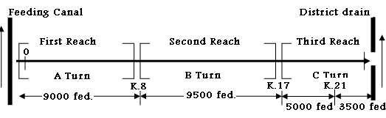

- What are the Components of Irrigation System?

- What is meant by “Furrow Irrigation” and “Flooding Irrigation”?

c- Calculate the area served for sec A,B,C for this distribution canal if f = 30%:
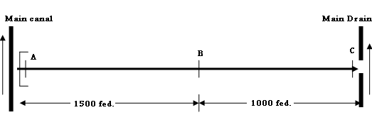
d- What are the meaning of:
1-The Synoptic Diagram of Canals,
2- Coefficient of Channel Roughness,
3- Longitudinal Sections for Irrigation and Drainage Channels,
4- Borrow Pits,
5- Expropriation Width.

