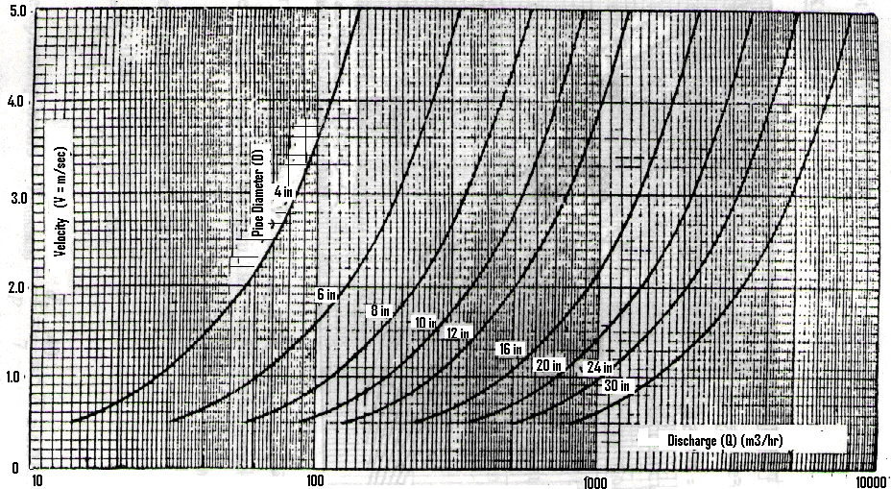
Chart (1): Selection of Main and Sub-main Lines Diameter
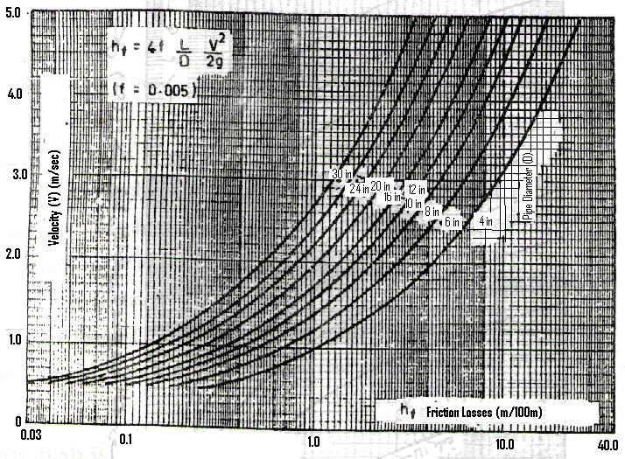
Chart (2): Friction Losses in Main and Sub-main Lines

